Date: 20/12/21

***Django framework***

***Django is a high-level Python web framework that enables rapid development of secure and maintainable websites.***

Diagram:

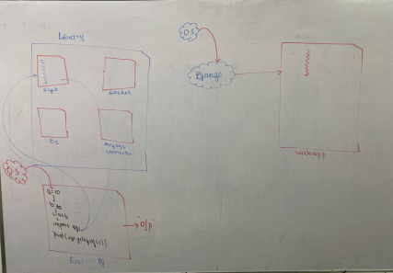

Library……………………….collection of module

Framework (Django)………collection of library

**Framework:**

It is collection of libraries.

**Library:**

It is collection of module.

**Module:**

It is a file which consists of statement, class, function, method, declaration and so on.

Introducing:

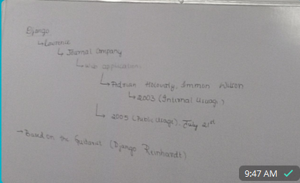

Features:

It is free and open source.

It is written in python language.

It follow MVT architectures pattern.

It is maintained by django software foundation (DSF).

The name of frame work was given in memory guitars django

The framework is used by several top website like google, yahoe, and etc.

***Installation of django software:***

In order to installed django framework comment is: ***pip install django***

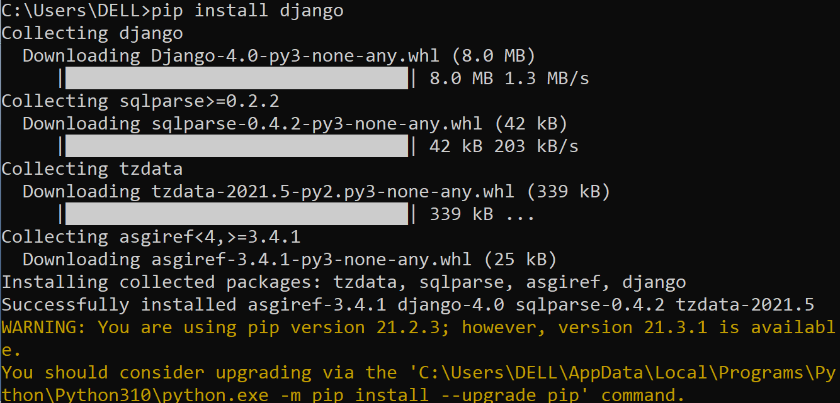

In order to check the framework is installed or not the comment is:

***pip show django***

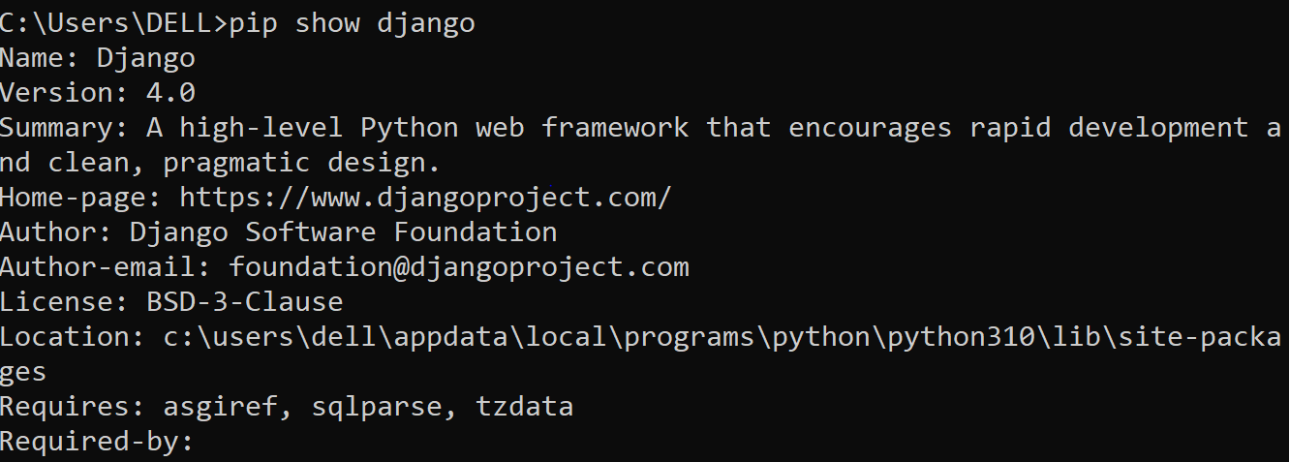

In order to specific version of django.

***pip install django ==version number.***

* In order to uninstalled django framework comment is: ***pip uninstall django***

**Project**

Application + configuration files = project

**Creating the project using django framework:**

Project name (folder)

__init__.py

Setting.py

Urls.py configuration files

Wsgi.py

Asgi.py

Manage.py

Comment:

django-admin startproject projectname

steps:

cd django

django-admin startproject firstprject

cd firstprject

dir

tree /f

To run the server the comment is: ***python manage.py runserver***

Create application

In order to create the application the comment is: ***python manage.py startapp application name***

Note:

**In order to the development server the comment is :** ctrl+c

Steps for creating project and application

Note:

Without creating project we cannot create application.

Step1: create a project ***django-admin start project project name***

Tree structure

In

**tree /f**

The folder name would be project name ( second project)

This folder consist of five file if you are using above django version above 2.2

**1.__init__.py**

This file in the django framework create folder as package

**2. Setting.py**

In this file we have to specific all project setting and configuration.

3. **URLS**

This file is used to map the request need by the user in order to execute specific function.

This file is used to navigate the control from project level to application level.

**4. Webserver gateway interface (WSGI)**

In this file we have to specific the development of an application on the cloud platform during hosting

It is used to provide interface between asynchronous python server (web server) and django framework

**5. Asynchronous server gateway interface(ASGI)**

**Manage.py**

It is considered to be as root file of the project

Using the manage.py we can create the application

***Create the application***

In order to create the application the comment is: ***python manage.py startapp appname***

Example

python manage.py startapp secondapp

***Comment:***

The moment we create the application inside the project using the comment: **python manage.py startapp appname**

***Steps: Two***

Creating application:

**The framework will internally create six files and two folders**

First folder name is migration

Second folder name is firstapp

**This particular folder consist of six files as:**

1. admin.py
2. apps.py
3. models.py
4. 4.tests.py
5. views.py
6. __init__.py

0nce the application is created we must configure the application a setting.py which is present at project level.

Before creating apps:

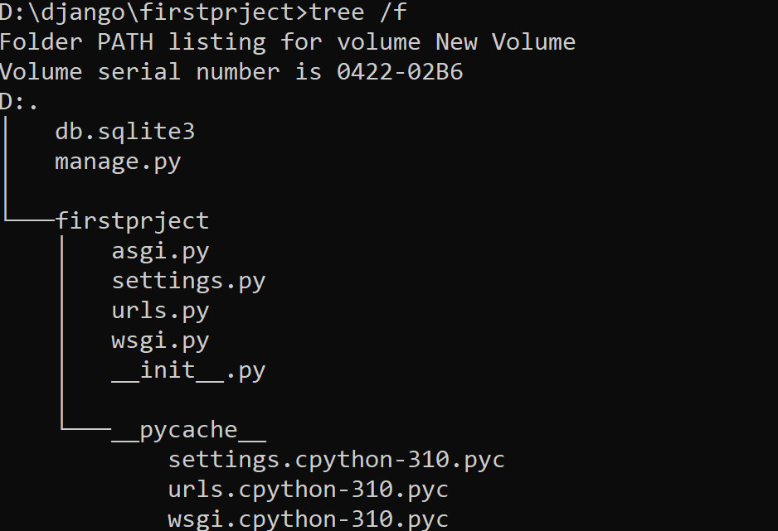

After creating apps:

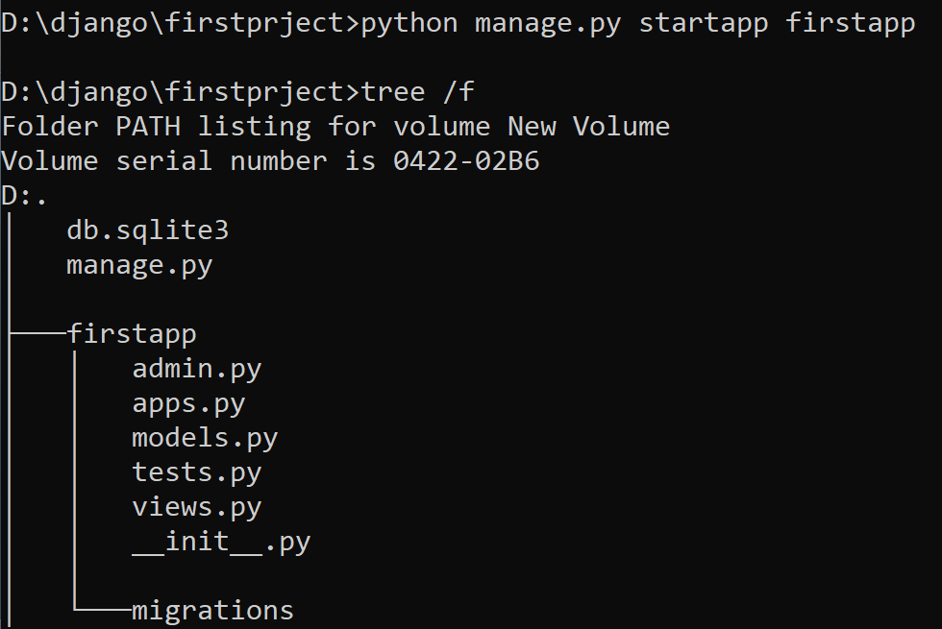

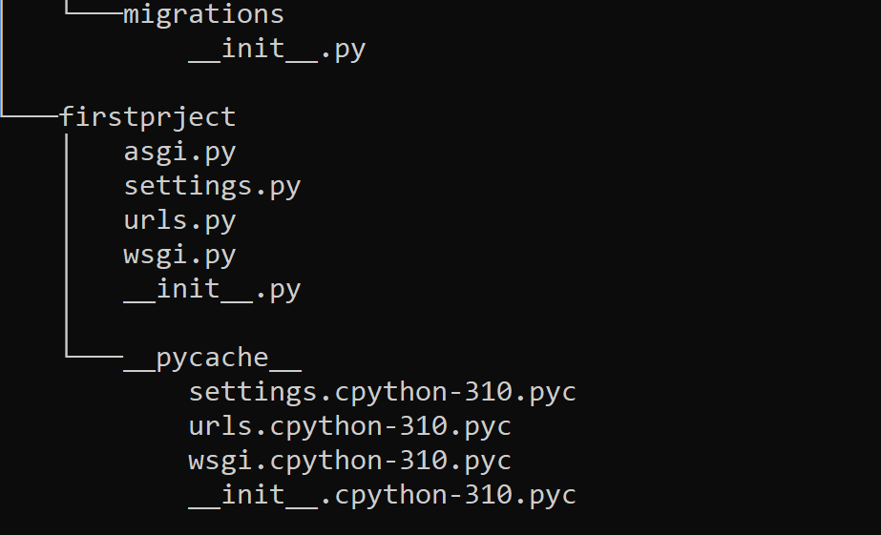

**Control flow of program:**

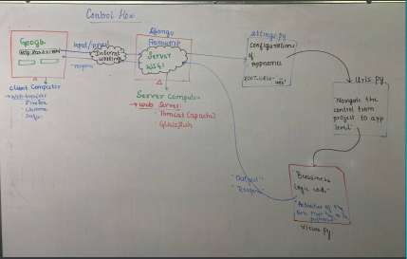

Second project (folder)

__init__.py

Setting.py

Urls.py

Configuration files

Wsgi.py

Asgi.py

Manage.py

The moment we create the project the django framework internally creates one file and one folder.

The file name is always manage.py

Mange.py is root file (therefore it is compulsory execute manage.py)

**Note**

In order to execute the manage.py the comment is python manage.py

Write a program to display a message on web browser using django framework

**Steps to perform**

Step1: Create a project(django-admin startproject projectname

)

Step2: Create application(python manage.py startapp secondapp)

Step3: Configuration the application in setting.py

Step4: Navigate the control from urls.py to views.py

Step5. Send the response from views.py to the web brow server

Write a program to display two massage hello word and welcome to django on the web browser

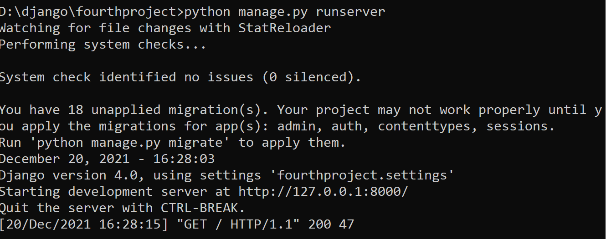

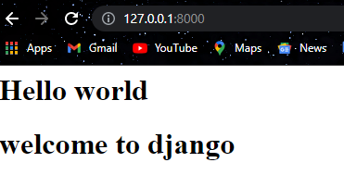

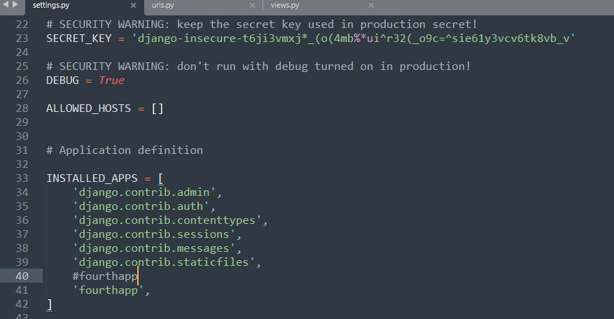

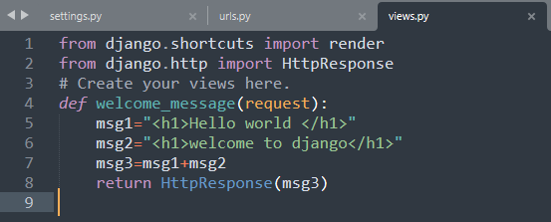

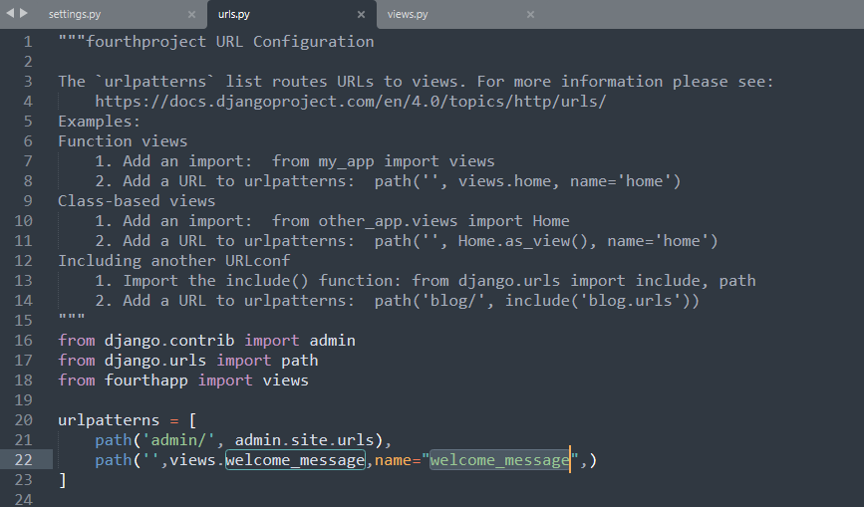

Date: 21/12/21

Control flow:

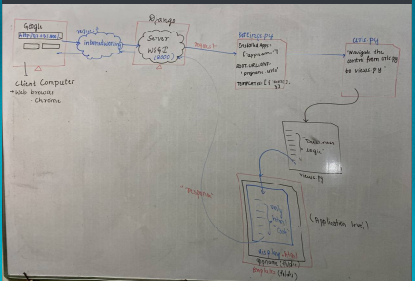

Tree structure:

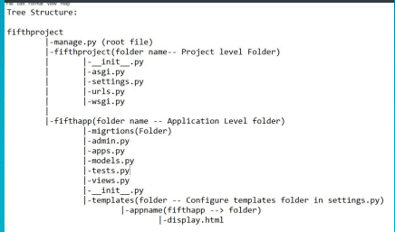

Write a program to the display message using Django framework using html file.

Steps:

Under app give right click to create template folder

Under template folder create app folder

Under app folder create html file

Under setting in Install_app add “appname” and in template add source from template(click find in folder).

Write a code in urls and views.

from fifthapp import views

urlpatterns = [

path('admin/', admin.site.urls),

path('',views.greeting),]

from django.shortcuts import render

# Create your views here.

def greeting(request):

print(request)

return render(request,'fifthapp/display.html')

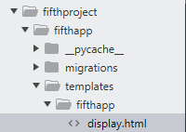

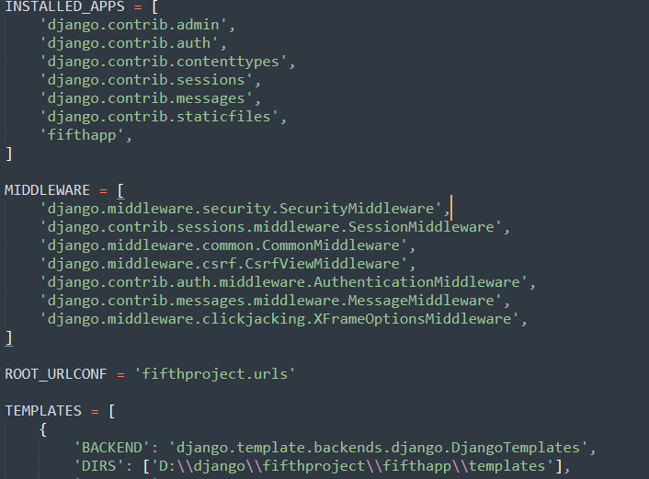

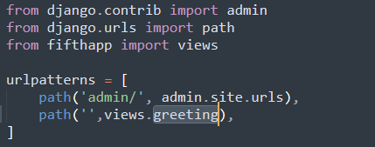

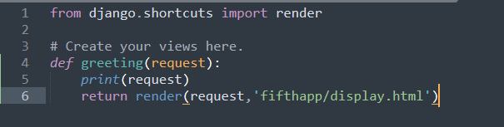

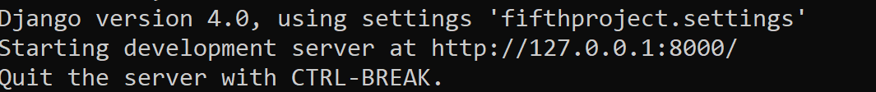

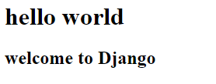

Write the python program to display current date and time on the web browser with the greeting.

Tree diagram:

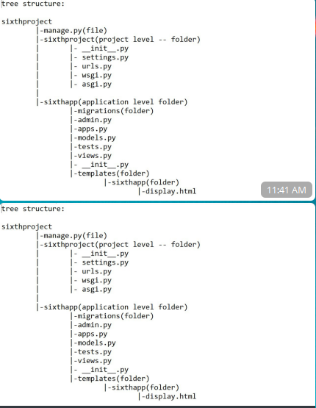

Steps:

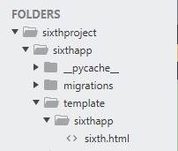

Setting part:

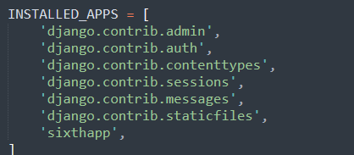

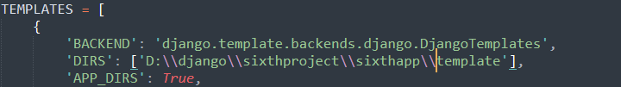

Urls parts:

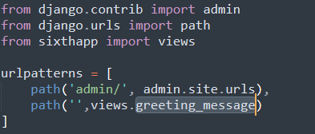

Views parts:

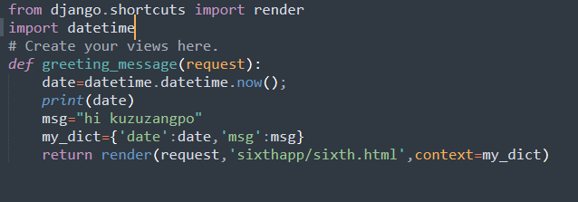

Html file:

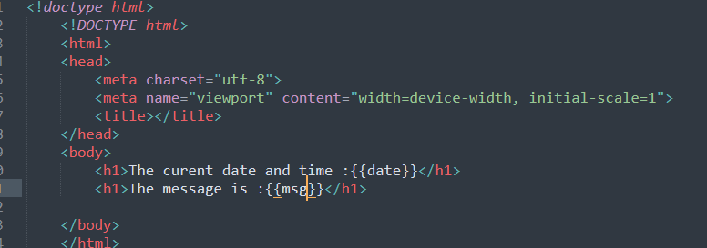

Output:

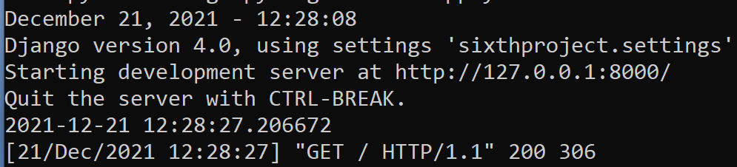

Output in web browser:

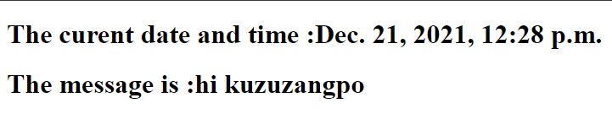

Write a python program to display current year.

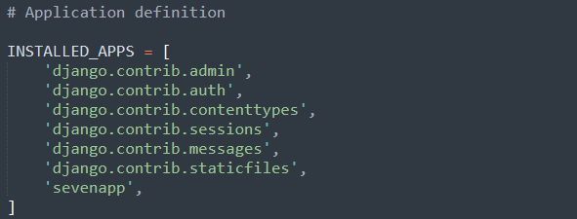

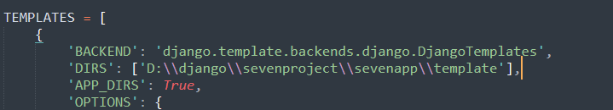

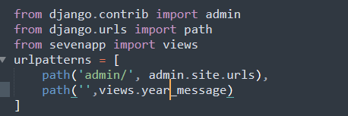

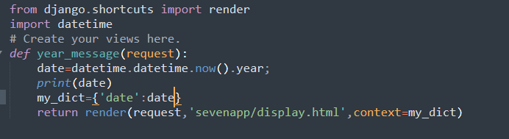

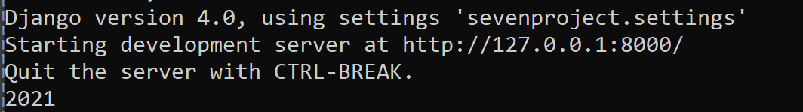

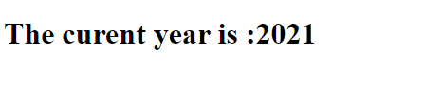

Write a program to display the greeting based on the current time.

Setting:

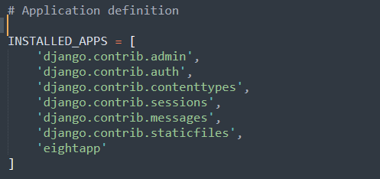

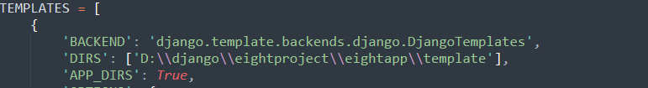

Urls:

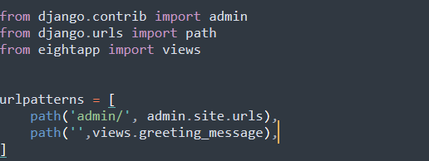

Views:

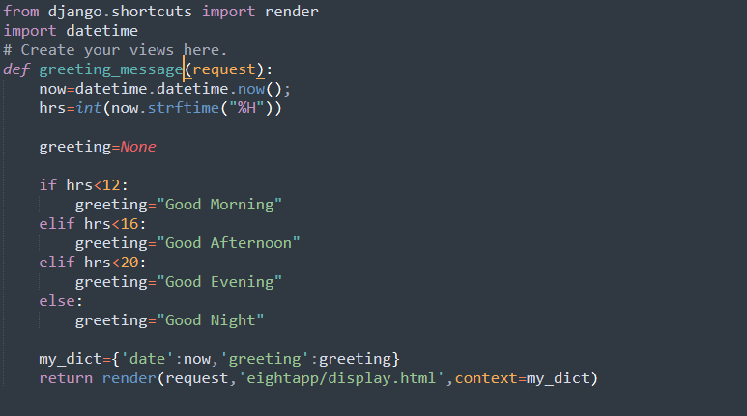

Html:

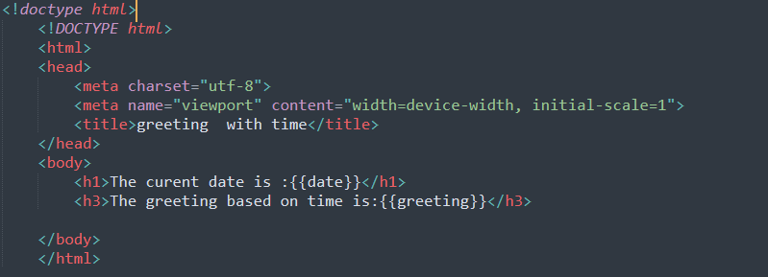

Output:

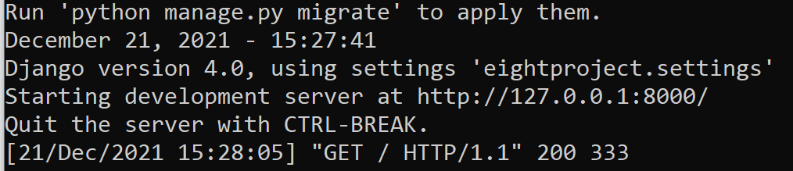

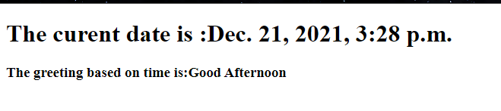

Date: 22/12/21

Write a program to display message and datetime by changing DIR templates

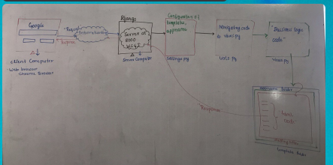

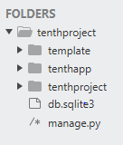

Setting:

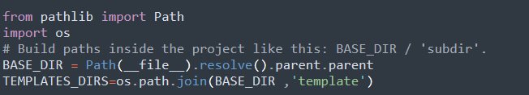

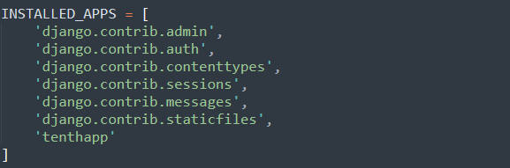

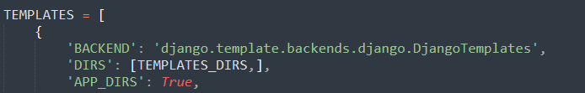

Output:

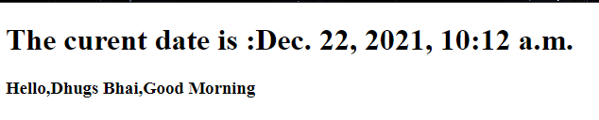

Display:

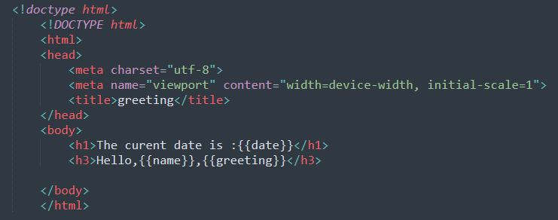

Views:

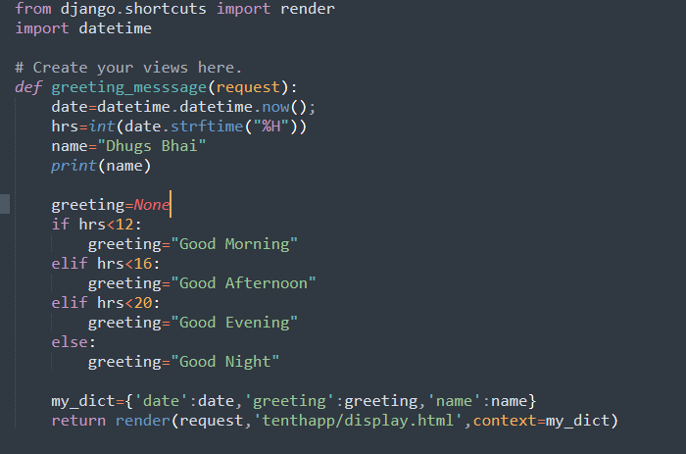

Urls:

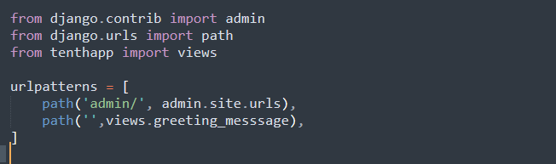

Write a program to display message and image using css and html template language.

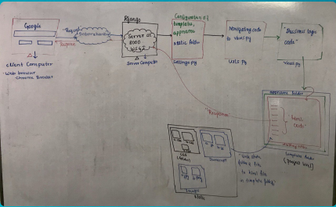

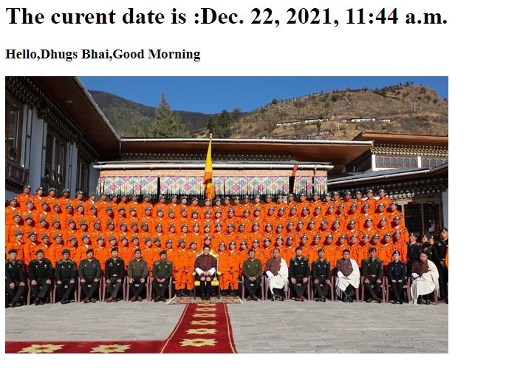

Write a program to create multiple application in the project.

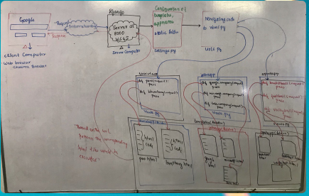

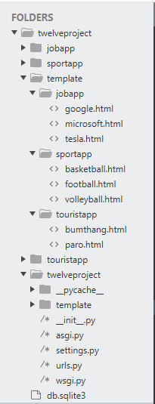

Python manage.py startapp jobapp

Python manage.py startapp sportapp

Python manage.py startapp touristapp

Setting:

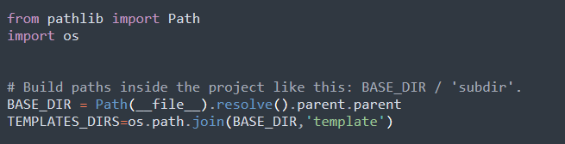

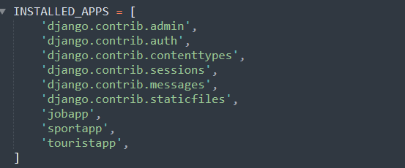

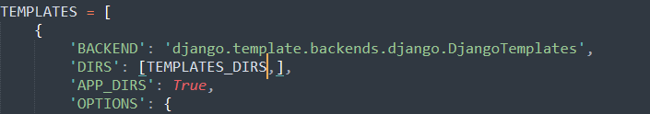

Urls:

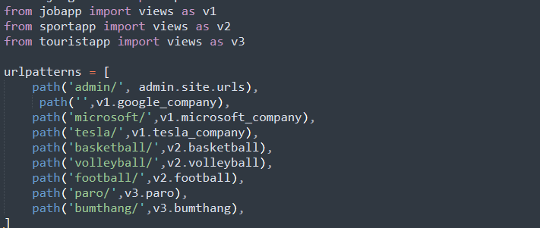

Jobapp views:

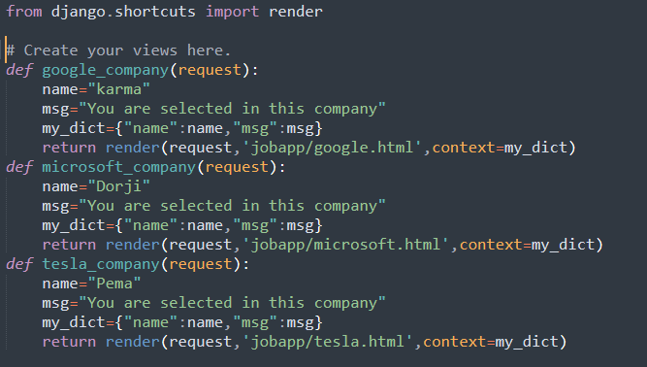

Sport views:

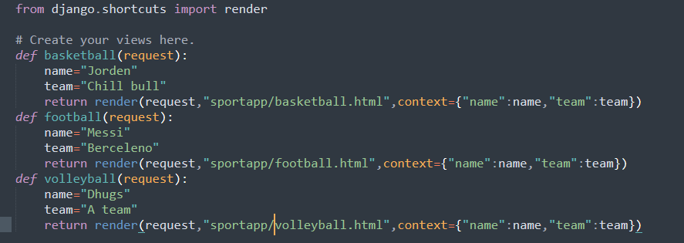

Tourist views:

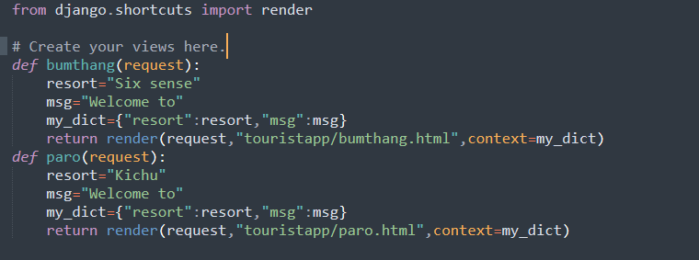

Template (folder under project) parts:

Jobapp parts:

Google.html:

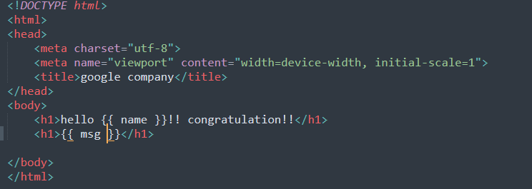

Microsoft.html:

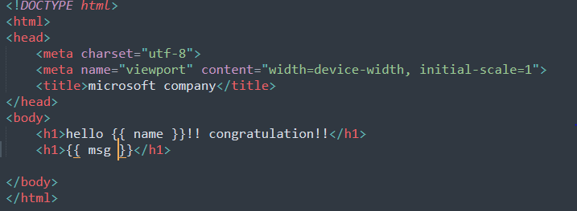

Tesla.html:

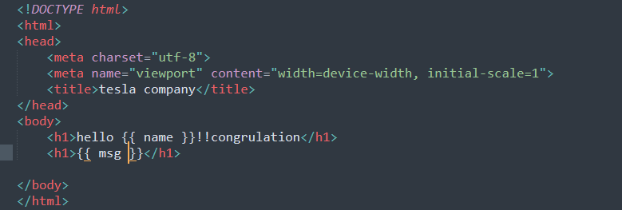

Sports parts:

Basket.html:

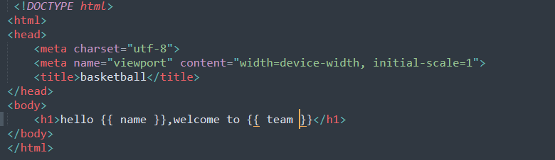

Football.html:

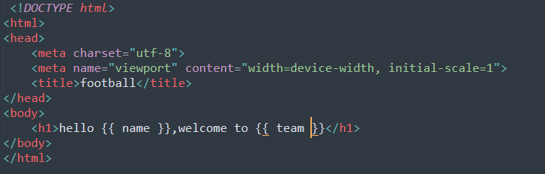

Volley.html:

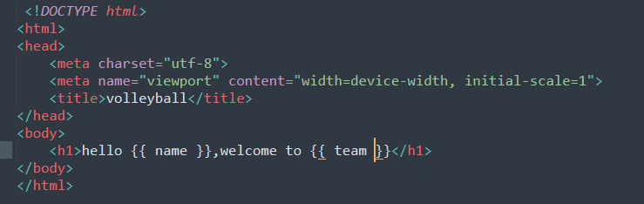

Touristpart:

Bumthang.html:

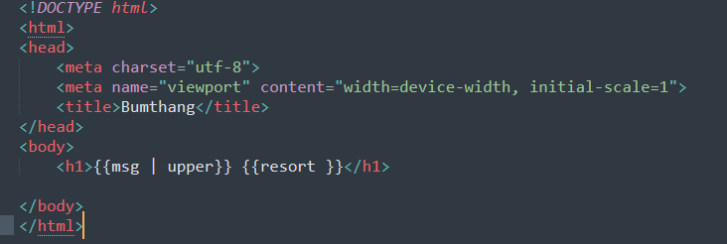

Paro.html:

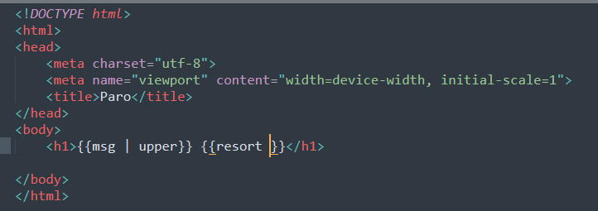

Output:

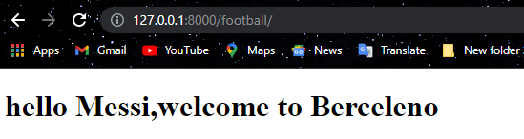

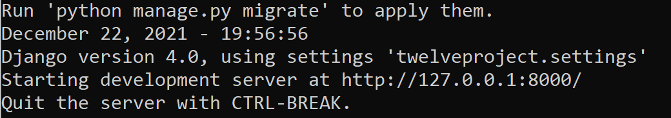

*Date: 23/12/21*

Write a program to create the urls.py at the app level and configuration the app in the project level.

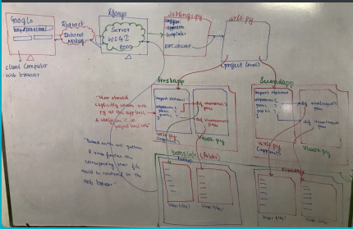

Setting:

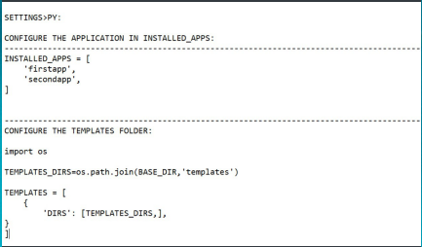

Project Urls:

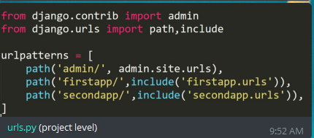

Firstapp urls:

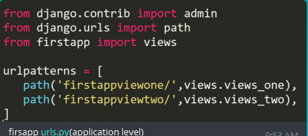

Firstapp views:

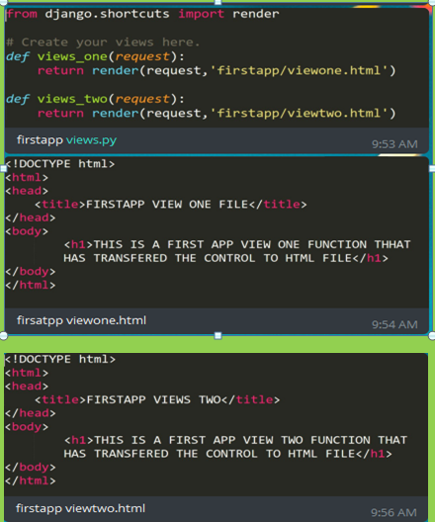

Secondapp urls:

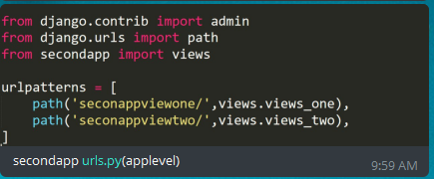

Secondapp views:

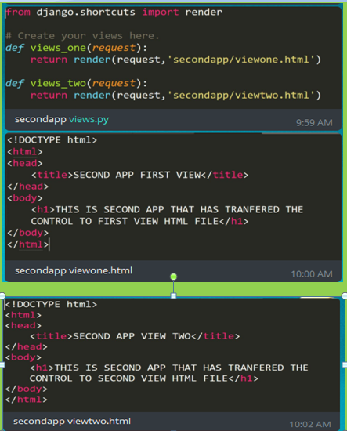

Output:

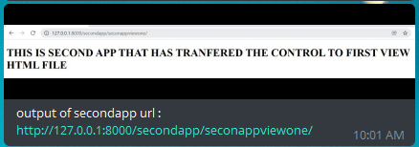

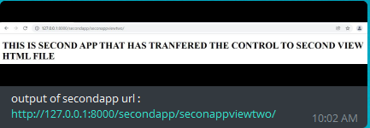

Changing cord number using command

Syntax

Python manage.py runserver cord number

Changing cord number in the file

